July 16th, 2006
Leonie, Gavin, Nadine
Another week gone; they seem to pass quickly. I have had a lot of troublesome breathing problems during the week. Not serious ‘attacks’ but lower-level trouble that has been difficult to control, even with larger amounts of medicine. I think it will get me one day just as it nearly did in 1985 when we were returning to Stanford after the Easter break.
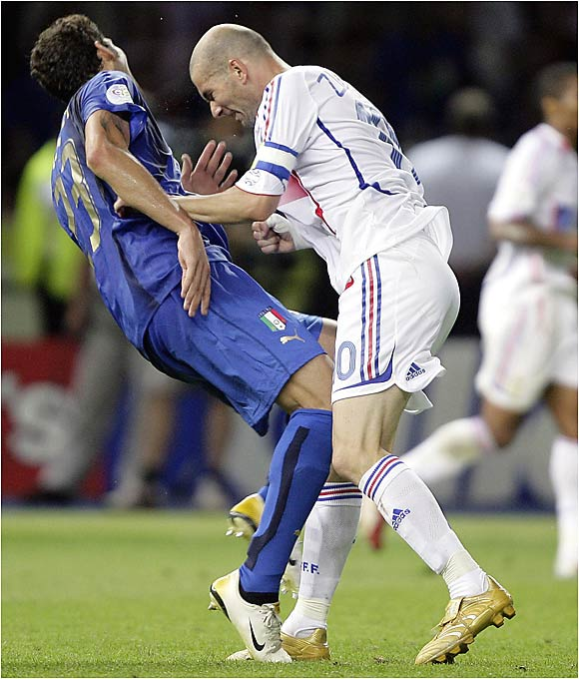
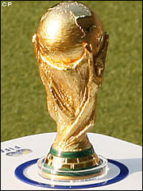
Not that much to write about. Didn’t watch any of the World Cup soccer matches. So, Italy won! They may not have won if one of their players had not ‘dived’ when being tackled in an earlier game against Australia, which resulted in a penalty kick. Italy scored and won the game. Still, professional fouls seemed to be the order of the day. And all the ref baiting that goes on; much more than in other sports. In Rugby, if a player argues with the ref, he can get a red card. And then, in the final game there was the infamous ‘head but’ by the French player. Although he should not have done it, I can understand why he did, if the comments supposedly made by the Italian player are true.
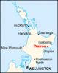
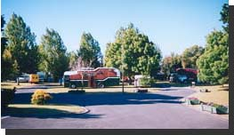
Got an e-mail from my brothers to say that one of my few remaining uncles died a few days ago, aged 92. This was Uncle Ron, who lived in a little town called Wairoa. You never met him, but when we were on the holiday in the campervan, we drove into his orchard then asked in a nearby shop where they told us he was on holiday in Papua New Guinea with one of his sons. We then stayed in a camping ground on the banks of a river (picture). Uncle Ron has another son, called Roger, whom we visited in Napier where his daughters went riding on horses.
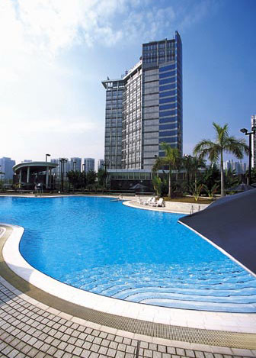
In spite of not feeling well, I still did exercise. Swam on three days, doing 4.5 km for the week. The water in the pool is very, very hot. A lifeguard said that it went up to 35⁰C!! Imagine it! On Friday, I did some of the laps at the deep end. The water there is actually a little cooler and the deep end is good because there is a vertical wall to push off from at each turn instead of the steps in the main part of the pool. The only disadvantage is that each length is just half that in the main pool, so there are many turns to make. Still, I might use this end from now until the water temperature drops.

This coming week I have two medical appointments. On Wednesday, I go to the hospital for a follow-up check. On Thursday, I go to see the dermatologist again, for what may now be a regular visit every couple of months or so.
The tri-nations match this weekend was between Australia and South Africa. Australia slaughtered SA 49 – 0.
That seems to be it for now.

Cheers

